**OSH AUTHORITIES – BULGARIA**

Source: <https://oshwiki.eu/wiki/OSH_system_at_national_level_-_Bulgaria>

* OSH Infrastructure

Scheme:

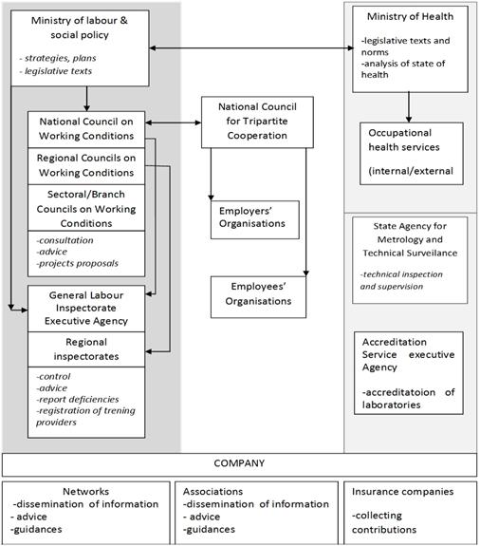

* OSH authorities and inspection services

|  |  |
| --- | --- |
| Name of the Authority | The Ministry of Labour and Social Policy (MLSP) |
| Link | <https://www.mlsp.government.bg/index.php?lang=_eng> |
| Short abstract | The MLSP is part of the Bulgarian Council of Ministers (the executive state body).MLSP is in charge with developing, coordinating and implementing the policy on labour, professional qualification, income and living standard, industrial relations, health and safety at work, social security and social assistance.  According to the Health and Safety at Work Law the tasks of MLSP in the field of health and safety at work are:   1. jointly with the Ministry of Health to analyze the status, trends and problems in providing healthy and safe working conditions and to propose measures for its improvement; 2. alone or with other ministries issues regulations on the provision of health and safety, organizes and coordinates the development of legislation in this area and establishes rules to ensure safe and healthy working conditions; 3. carries out an integrated control trough the Executive Agency "General Labour Inspectorate" of legislative compliance and fulfillment of obligations to ensure healthy and safe working conditions in all sectors and activities regardless of the form of ownership; 4. establishes the terms and requirements for training, measurements and consulting in the field of safety at work; |
| Link to OSH wiki | <https://oshwiki.eu/wiki/OSH_system_at_national_level_-_Bulgaria> |

|  |  |
| --- | --- |
| Name of the Authority | General Labour Inspectorate (Изпълнителна агенция "Главна инспекция по труда" - ИА "ГИТ") |
| Link | http://www.gli.government.bg/en |
| Short abstract | General Labour Inspectorate Executive Agency – GLI EA is subordinated to MLSP. It is in charge with monitoring legal compliance and reporting legislative deficiencies to MLSP. It provides information and technical advice to both employers and employees. GLI EA has Labour Inspection offices in the administrative regions of Bulgaria. |
| Link to OSH wiki | <https://oshwiki.eu/wiki/OSH_system_at_national_level_-_Bulgaria> |

|  |  |
| --- | --- |
| Name of the Authority | The Ministry of Health (Министерство на здравеопазването) |
| Link |  |
| Short abstract | The Ministry of Health leads specific activities related to health protection, cooperates with MLSP in elaborating laws and norms and coordinates occupational health services. Jointly with MLSP it conducts annual analyses of working conditions and proposes measures. |
| Link to OSH wiki | <https://oshwiki.eu/wiki/OSH_system_at_national_level_-_Bulgaria> |

Internal link to enforcement indicator by MS

* Compensation and insurance bodies

|  |  |
| --- | --- |
| Name of the Body | National Social Security Institute (NSSI): |
| Link | <http://www.noi.bg/en/> |
| Short abstract | Bulgarian social security contributions are managed by the National Social Security Institute. According to HSWL employees must have compulsory social security contribution for work accidents and occupational diseases paid by the employer, which is part of the social security system.  In addition, employees engaged in work where there is danger to life and health, must be insured for the risk "accident" by the employer under the terms and procedures established by the Council of Ministers. In determining the terms and conditions of this insurance the economic activity of the enterprise and the national average level of the coefficients for frequency and severity of accidents is considered. The sectors are defined yearly (MLSP) and usually include branches like construction, wood processing, mining and machine building that have accidents’ rates higher than the national average.  There are also differences for the pension contribution of employees that worked in hazardous conditions. Those employed under the conditions of first and second labour category have mandatory contributions in a supplementary professional pensions fund. Activities under the first and second labor categories are presented in the Ordinance for Labor Categorization upon Retirement[35]. The categories are assigned according to the nature and specific conditions of work.  The contribution is 12%, for first category and 7% for the second category. These contributions are made exclusively at the employer’s expense[36] and cover early retirement of workers. |
| Link to OSH wiki | <https://oshwiki.eu/wiki/OSH_system_at_national_level_-_Bulgaria> |

|  |  |
| --- | --- |
| Name of the Body | National Revenue Agency |
| Link | <http://www.nap.bg/en/> |
| Short abstract | Since 2006 notifications about labor contracts, declarations about insured persons, and returns about social security contributions due are also filed at the offices of the National Revenue Agency. Also at the Agency are filed the returns about the health insurance contributions for persons insured by the state budget, as well as the returns for social security and health insurance contributions paid in advance. |
| Link to OSH wiki | <https://oshwiki.eu/wiki/OSH_system_at_national_level_-_Bulgaria> |

* Research institutes

|  |  |
| --- | --- |
| Name of the Institute | National Centre of Public Health Protection (NCPHP) |
| Link | <http://ncpha.government.bg/index.php?lang=en> |
| Short abstract | The National Center of Public Health and Analyses (NCPHA) is a structure within the national healthcare system and carries out activities for protecting public health, promoting health and preventing diseases, providing information for healthcare management.  In conformity with its main activities for the purpose of protecting and promoting health the NCPHA examines the population's health status and the relationship with environmental factors and living conditions; conducts epidemiological surveys and evaluates risk factors for chronic non-communicable diseases; participates in the development, coordination and performance of national programmes and action plans as well as in international research programmes oriented to strengthening public health (including mental, reproductive and sexual); carries out intervention activities, training workshops and publishes information and methodical materials; assesses exposure and health risk for the population from the impact of biological, chemical and physical hazards on the ambient and working environment as appropriate recommendations have been prepared; conducts monitoring on nutrition and nutritional status of the population and develops Manuals for nutrition of target population groups. |
| Link to OSH wiki | <https://oshwiki.eu/wiki/OSH_system_at_national_level_-_Bulgaria> |

|  |  |
| --- | --- |
| Name of the Institute | The Institute for Population and Human Studies |
| Link | <http://www.iphs.eu/n/en/> |
| Short abstract | The Institute for Population and Human Studies is an academic centre for theoretical and applied research in different fields of demography and psychology.  The mission of IPHS is to carry out demographic and psychological research aimed at studying regularities and determinants of population and individual development. Analyses of reproduction processes and psychological mechanisms for regulation of behaviour with the purpose of assisting institutions in the implementation of strategies and policies for social and personal growth in the process of European integration and world globalization. |
| Link to OSH wiki | <https://oshwiki.eu/wiki/OSH_system_at_national_level_-_Bulgaria> |

|  |  |
| --- | --- |
| Name of the Institute | The Institute for Social and Trade Union Research-ISTUR |
| Link | <http://www.knsb-bg.org/index.php/deinosti1/2015-04-03-15-00-57> |
| Short abstract | The main areas of activity of the ISTUR are research, consultations and training in the following areas: development of trade unionism and industrial relations - historical development; structures; social partnership; collective bargaining; collective labor disputes; protest actions and strikes; an international trade union movement; labor market and trade union strategies; privatization; social policy - living standards, prices, income, social protection. |
| Link to OSH wiki | <https://oshwiki.eu/wiki/OSH_system_at_national_level_-_Bulgaria> |

* Prevention institutes

|  |  |
| --- | --- |
| Name of the Institute | National Centre of Public Health and Analyses  Department |
| Link | <http://hp-whp.ncphp.government.bg/index.php?page=en> |
| Short abstract | The National network of health and safety promoting companies (NNHSPC) was designed as a social network – organization and actions for mobilization and facilitation of the social support for activities focused on promotion of health and safety at work. The National Centre of Public Health and Analyses NCPHA (formerly the National Centre of Public Health Protection NCPHP) in Sofia, Bulgaria, incorporates units with 50 years of experience in the field. Its main activities include research and development, expert consultancy, methodological and training activities in the area of public health protection, assessment of health risks due to occupational and environmental factors, personal behaviour and lifestyle, health promotion and integral diseases prevention |
| Link to OSH wiki | <https://oshwiki.eu/wiki/OSH_system_at_national_level_-_Bulgaria> |

* Standardization bodies

|  |  |
| --- | --- |
| Name of the Body | Bulgarian Institute for Standardization (BDS): |
| Link | <http://www.bds-bg.org/en> |
| Short abstract | The Bulgarian Institute for Standardization (BDS) is the national executive body for standardization in the Republic of Bulgaria.  BDS develops, accepts and approves Bulgarian standards, participates in the work of international and European organizations for standardization, as its main target is to defend the Bulgarian interests in that sphere. |
| Link to OSH wiki | <https://oshwiki.eu/wiki/OSH_system_at_national_level_-_Bulgaria> |